GENERAL CONTENT
ABOUT RECUPEL

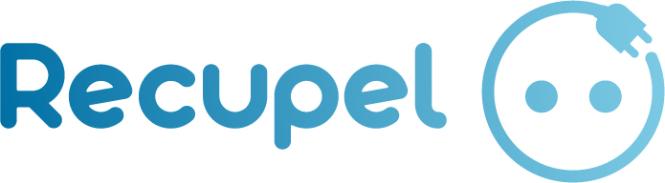

WHAT IS RECUPEL?
Recupel is a Belgian non-profit association that organises the collection, sorting, processing and recycling of used or broken electrical and electronic appliances and light bulbs.
So what is its main goal?
Recupel works together with specialised transport and processing companies, selected for their expertise in dismantling, decontamination and reuse. The reusable raw materials extracted are used to manufacture new appliances or materials.

RECUPEL’S MISSION
Recupel ensures that used or broken electrical and electronic appliances and light bulbs are collected and recycled efficiently, in a way that is both sustainable and economically efficient.
All these unused/unusable appliances are made up of different raw materials. If they are dangerous to the environment, they are disposed of by a specialised processing company. The other raw materials are transformed, recycled and reused to make new products.

CTA: Find out what Recupel recycles

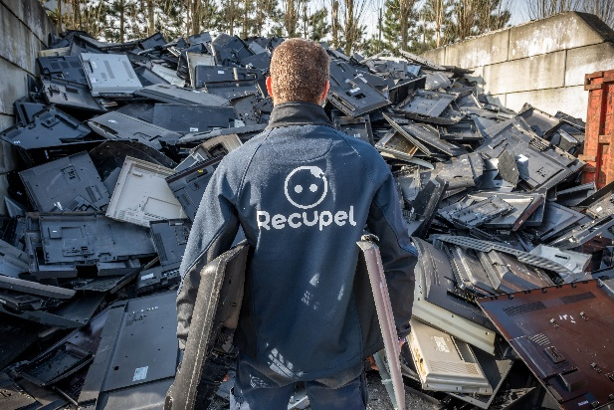

RECUPEL IN FIGURES
119,654 tonnes of electrical and electronic appliances and light bulbs collected in 2021
50,121 tonnes of small household appliances
28,691 tonnes of large ‘white goods’ (washing machines, tumble dryers, dishwashers etc.)
23,548 tonnes of fridges and freezers
9,571 tonnes of televisions and monitors
1,219 tonnes of light bulbs
3 tonnes of smoke detectors

41 million devices collected in 2022

You are fantastic!
In 2022, each person in Belgium brought 10.33 kg of used electrical and electronic appliances and light bulbs to a Recupel collection point.

FIGURES WITH REGARDS TO REUSE
3,818,80 kg household appliances were reused
The reuse figure is up compared to 2021. This is good news for several reasons. By giving discarded devices a new lease of life, we save a lot of energy and raw materials. Reuse also provides an affordable option for people with low incomes. And it creates jobs, especially for people without access to the regular employment market. There is a whole network around reuse, but the highlights of 2022 were undoubtedly the second-hand shops and reuse centres, with a million kilograms more reuse than last year. This brings us to a grand total of 3,818,805 kilograms reuse in 2022!

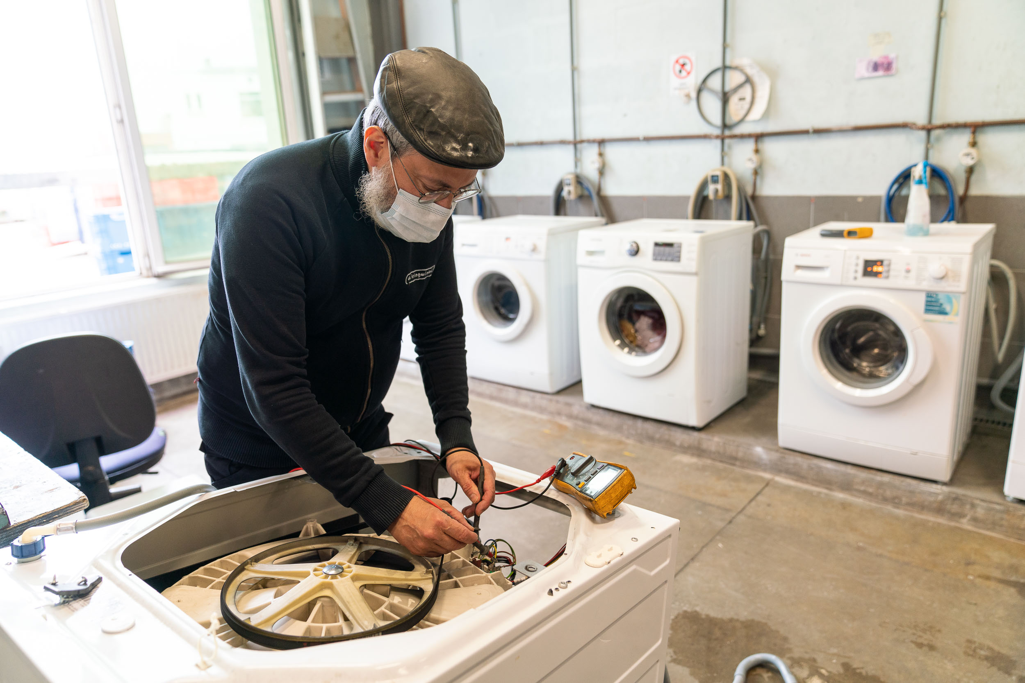© Jasper Leonard

2,527,137 kg second-hand shops and reuse centres
In 2022, reuse through second-hand stores and reuse centres grew by almost 1 million kilograms compared to 2021. This was a very strong result.
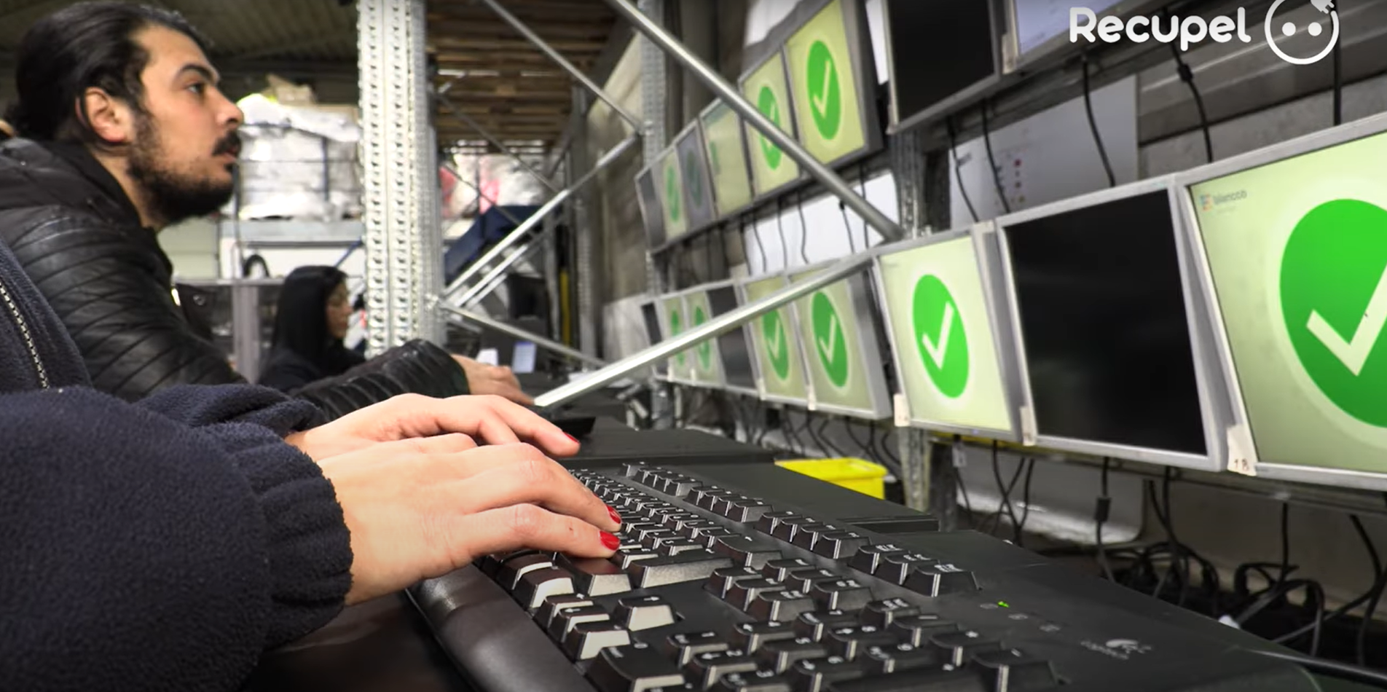

550,852 kg charter operators
We use charter collectors to collect devices and appliances. A number of them, such as Out of Use and CTG, even organise reuse for the devices and appliances collected. Over the past year, they gave half a million kilos of devices and appliances a new home.
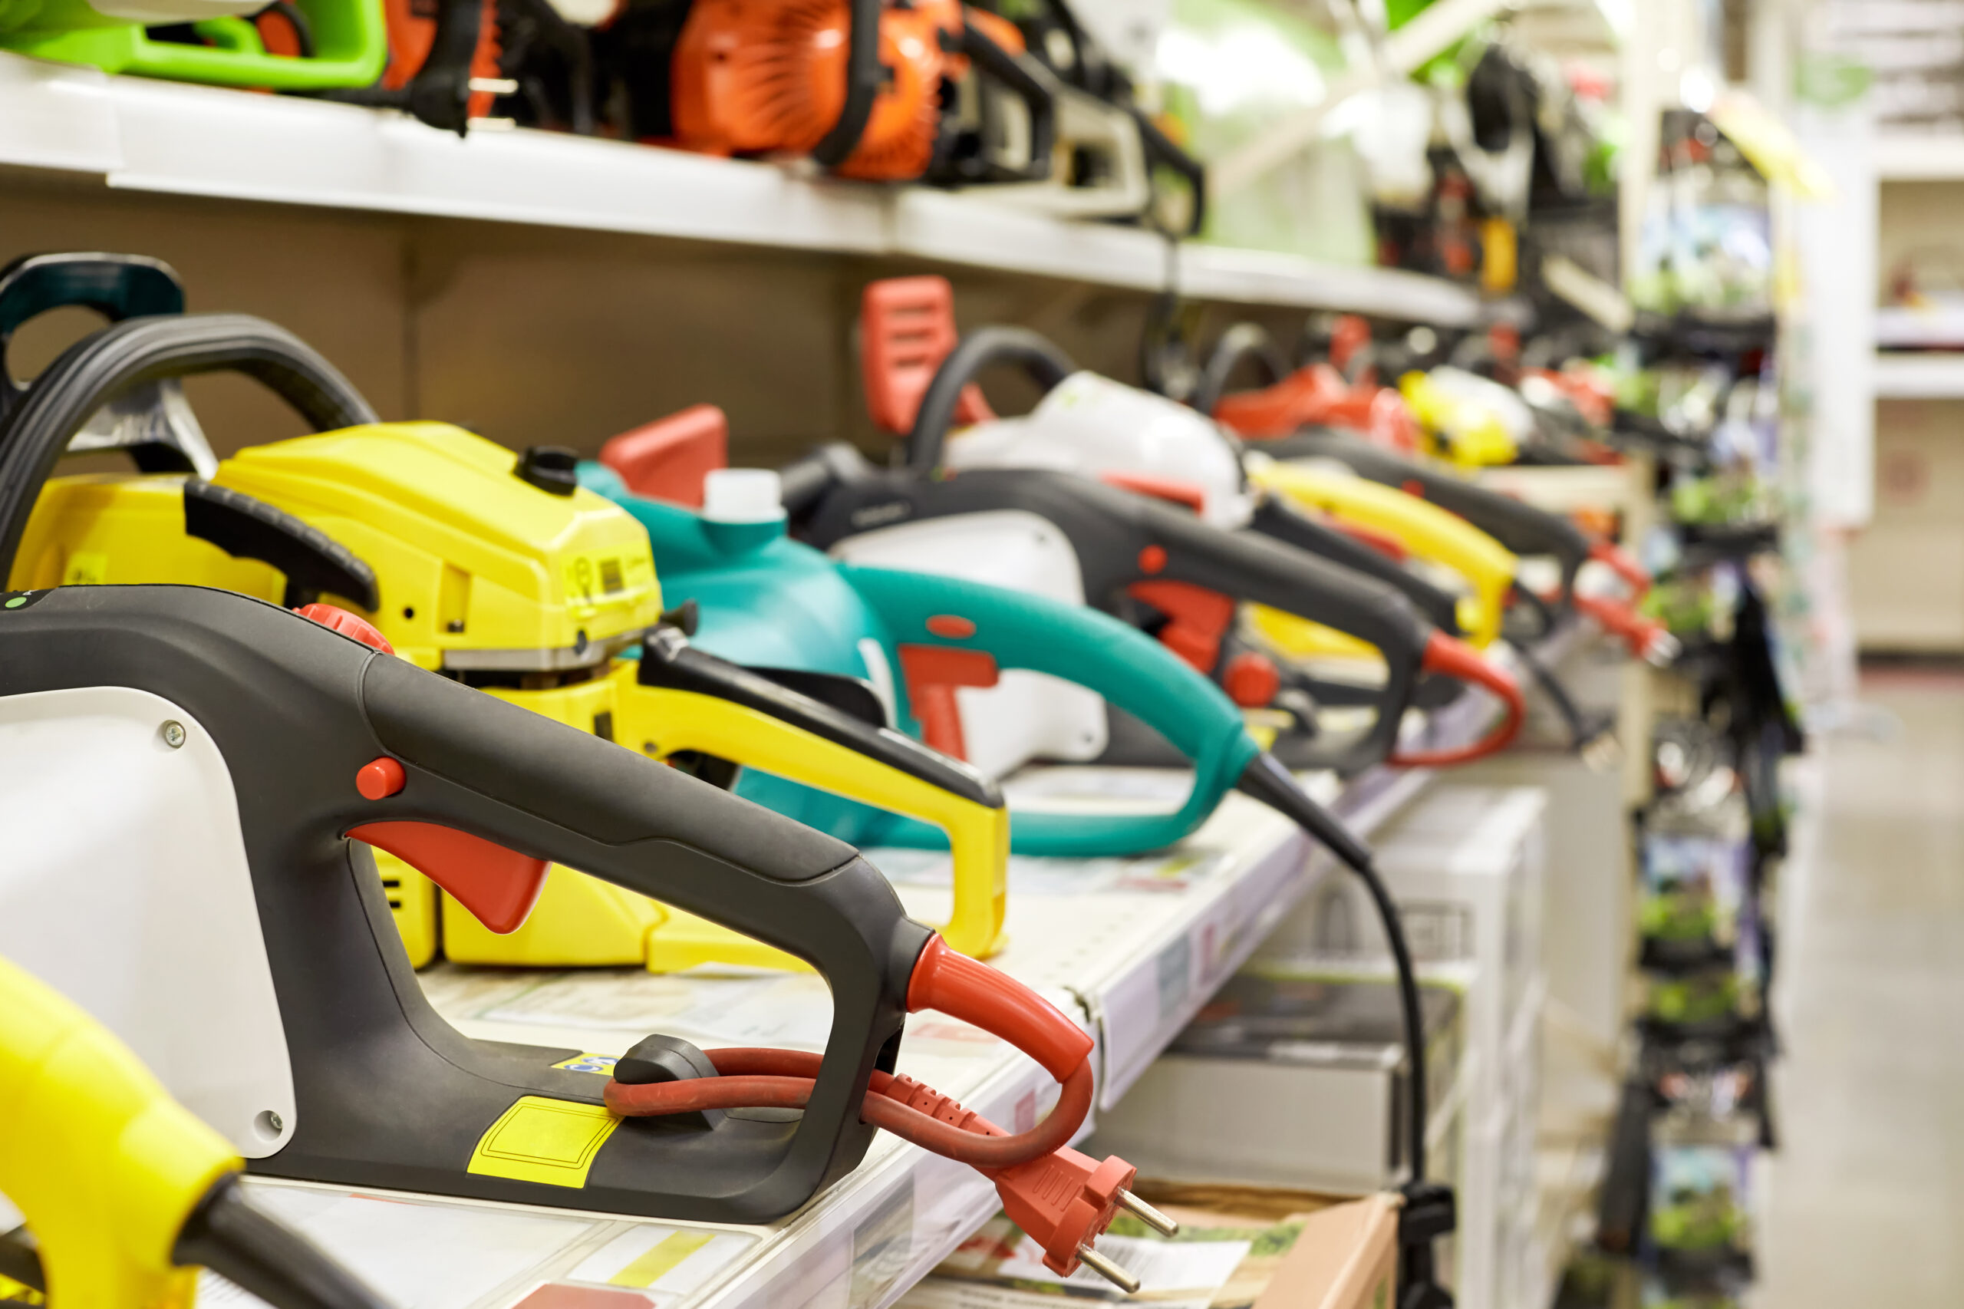
740,816 kg members
The producers and sellers of electrical and electronic appliances are also supporting reuse. In 2022, Recupel members brought 740,816 kilograms of discarded and returned devices into circulation again.
CTA: Want to learn more? Read Recupel’s 2022 annual report

WHO ARE RECUPEL’S PARTNERS?
Recupel works with various partners for the collection, treatment and reuse of used or broken electrical and electronic appliances and light bulbs.
- Collection: container parks, Recupel small electronics and light bulb collection points provided in supermarkets, DIY and electrical goods stores, and Recupel fridge collection points at electrical goods and kitchen appliance stores.
- Processing: specialised processing companies sort and dismantle appliances that are no longer in use or usable. They eliminate harmful gases, extract the raw materials and recycle them. These raw materials can be used to manufacture new appliances.
- Reuse: second hand shops, recycling shops and reuse centres repair and recondition appliances that are still usable in order to sell them second hand.

CTA: Find a Recupel collection point
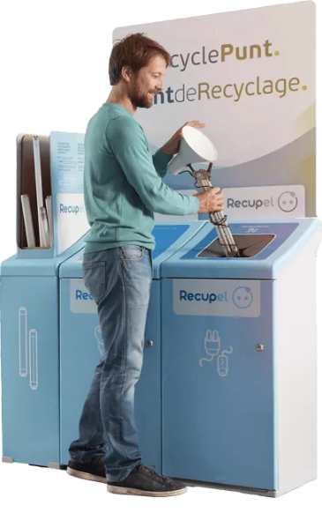

WHAT IS THE RECUPEL CONTRIBUTION USED FOR?
Recupel members (manufacturers and importers of electrical and electronic appliances and light bulbs) pay the organisation a contribution for each appliance brought onto the Belgian market. The amount of this ‘Recupel contribution’ is stated on your till receipt.
These contributions enable Recupel to finance all its activities (collection, transportation, recycling, communication, etc.). That means that when you buy an appliance, you are guaranteed that it will be given a new lease of life when it is no longer in use or usable: take it to a Recupel point and Recupel will ensure that it is recycled into new raw materials or given a second life through the second hands shops.

CTA: Want to find out more about what the Recupel contribution is used for? Click here

WANT YOUR OLD APPLIANCE TO BE COLLECTED? IT’S OBLIGATORY!
When you buy a new household electrical appliance (fridge, washing machine, TV, etc.), the seller is obliged to take back your old appliance, even if you bought it from a different store.

Where is your appliance collected? From the place to which your new appliance is delivered.
What is a large appliance? Electrical appliances whose:
- longest side is more than 1.5 m long
- size is greater than 3 m (measured as follows: 1 x length + 2 x width + 2 x height)
- external weight is greater than 30 kg.

WHERE CAN YOU RETURN YOUR OLD ELECTRICAL AND ELECTRONIC APPLIANCES AND LIGHT BULBS?
You have several options:

Does the appliance work?
If your appliance still works or can be repaired, take it to a second hand shops. It will be given a second lease of life and sold for an affordable price.

CTA: What should you do with appliances you no longer use? Find out here

If your appliance no longer works
You should return large appliances to the store where you are buying an equivalent appliance, because the store is obliged to take the old one back. You can also have it collected from your home when your new appliance is delivered.
For small electrical or electronic devices (mobile phones, electric razors, MP3 players – any devices smaller than your head, in fact) and light bulbs, go to a Recupel recycling point or container park.

CTA: Find a Recupel collection point

WHY RECYCLE YOUR OLD ELECTRICAL AND ELECTRONIC APPLIANCES?
If they still work and you don’t use them, why not give them a second lease of life? This is what second hand shops do.
What if they are broken? Don’t leave them lying around in a cupboard, cellar, shed or attic, but give them to Recupel instead. That way you can help to create a genuine circular economy, because appliances are made of materials that can be recovered, processed and reused to manufacture new products. Recupel manages to recycle up to 90% of the components of an average appliance.

Watch out for harmful substances!
Don’t throw appliances in your household rubbish bin, because many of them contain harmful substances and materials that can pollute the environment for a very long time. Recupel works with partners specialised in processing them in order to care for the environment.

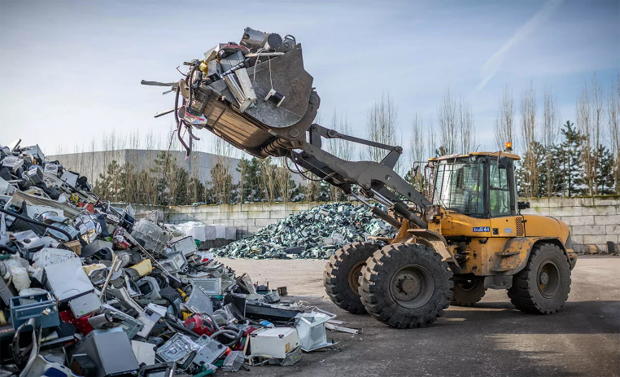

TOPICS

WHY RECYCLE YOUR OLD ELECTRICAL APPLIANCES?
If they still work and you don’t use them, why not give them a second lease of life? This is what second hand shops do.
What if they are broken? Don’t leave them lying around in a cupboard, cellar, shed or attic, but give them to Recupel instead. That way you can help to create a genuine circular economy, because appliances are made of materials that can be recovered, processed and reused to manufacture new products. Recupel manages to recycle up to 90% of the components of an average appliance.

Watch out for harmful substances!
Don’t throw appliances in your household rubbish bin either, because many of them contain harmful substances and materials that can pollute the environment for a very long time. Recupel works with partners specialised in processing them in order to care for the environment.

JOIN THE CLEAN-UP
Did you know that many electrical and electronic devices contain harmful substances and materials that can pollute the environment for a very long time if they are not processed or recycled properly?
By taking your old appliance that you no longer use to a Recupel collection point, you can be sure that it will be processed appropriately by Recupel’s recycling partners who abide by strict charters to limit their environmental impact.

WHAT IS URBAN MINING?
Recupel’s recycling partners extract materials such as plastic, metal, glass and even precious metals such as zinc, gold and silver directly from old appliances lying about in our cupboards, cellars, attics, garages and sheds. This is called ‘urban mining’. It is the exact opposite of conventional mining, which often poses environmental and ethical problems.

CTA: Discover 7 good reasons why urban mining is better than conventional mining here

What's more, on average Recupel manages to recycle up to 90% of the components of old electrical or electronic appliances. It transforms and reuses them to make new products.

YOUR OLD ELECTRICAL/ELECTRONIC APPLIANCE: VALUABLE WASTE
Did you know that your electrical and electronic appliances often contain rare and precious metals such as gold, silver, copper, nickel and palladium? These are resources that are likely to run out. So rather than throwing away used electrical or electronic appliances and continuing to plunder the Earth with conventional mining – which is very polluting – it is much better to transform this ‘waste’ into new raw materials. This is Recupel’s mission, and the reason why it collects, sorts and recycles your used electrical/electronic appliances and light bulbs.

THE CIRCULAR ECONOMY: JOIN THE VIRTUOUS CIRCLE
Whether your old electrical or electronic appliance is broken or still working, give it to Recupel to recycle. That will make you part of a genuinely virtuous circle, the circular economy. How does it work? By reusing materials and raw materials wherever possible.

- Is your device still working or just slightly faulty? Drop it off at a second hand shops. It will be reconditioned to give it a second lease of life and resold for an affordable price.
CTA: Find out here how second hand shops reduce our mountain of waste
- Is it well and truly broken? Recupel is committed to recovering up to 90% of its components and transforming them so that they can be reused to manufacture new products.

